

**LA GRANDEE INTERNATIONAL COLLEGE**

**Simalchaur, Pokhara Nepal**

**Final defence**

On

**“Decentralize Academe ‘Dacademe’ ”**

**Submitted to:**

Bachelor of Computer Application (BCA) Program

In partial fulfilment of the requirements for the degree of BCA under

Pokhara University

**Submitted by:**

|  |  |  |  |
| --- | --- | --- | --- |
| **Name:** | **Course** | **Semester** | **P.U. Registration Number** |
| Sangam Subedi | BCA | 6th | 2021-1-53-0366 |
| Amit Baral | BCA | 6th | 2021-1-53-0346 |
| Prabin Shrestha | BCA | 6th | 2021-1-53-0358 |

**Date:18/01/2025**

**Acknowledgement**

We would like to express our gratitude to our BCA coordinator **Mr. Kundan Chaudhari**, Project supervisor **Mr. Sunil Sapkota** and LA Grandee International Collage for their support and contributions to the development of Dacademe.

This project is done for the in partial fulfilment of the requirements for BCA (Bachelor of Computer Application) program under Pokhara University. Our project was made possible by the effort and dedication of our team members. We thank our dedicated team for their hard work and contributions to the game. We are grateful for the guidance and mentorship provided by our respected sir **Mr. Sunil Sapkota**.

Sincerely,

Amit Baral

Prabin Shrestha

Sangam Subedi

**Declaration for**

**“Dacademe”**

**Student’s Declaration**

We, **Sangam subedi**, **Prabin Shrestha** and **Amit Baral** being students of the sixth semester at LA GRANDEE International College, Faculty of Science and Technology ‘kha’, Pokhara University, do hereby declare that the project proposal submitted to the aforementioned institution is an original work completed by us in partial fulfilment of the requirements for the Bachelor of Computer Application (BCA) program, under the supervision of Sir **Mr. Sunil Sapkota**. We further state that no resources other than those specifically listed have been utilized in the completion of this project.

Name: Sangam Subedi Name: Amit Baral

Class Roll No.: 22 Class Roll No.: 2

PU-Registration No.: 2021-1-53-0366 PU-Registration No.: 2021-1-53-0346

Semester: 6th Semester Semester: 6th Semester

**Date: 18/01/2025 Date: 18/01/2025**

Signature: ............... Signature: ...............

Name: Prabin Shrestha

Class Roll No.: 14

PU-Registration No.: 2021-1-53-0358

Semester: 6th Semester

**Date: 18/01/2025**

Signature: ...............

**Supervisor’s Declaration**

I hereby recommend that this project entitled “**Dacademe**” is done under my supervision by **Prabin Shrestha,** **Sangam Subedi, Amit Baral** during their sixthSemester in partial fulfilment of the requirements for the degree of **BCA** under **Pokhara University** is completed to my satisfaction and be processed for final evaluation.

____________________________

**Mr. Sunil Sapkota**

**Date:18/01/2025**

# Abstract

D-Academe is a decentralized online learning management system that truly rethinks ways in which to break traditional barriers to learning. It focuses on providing a smooth, flexible, and inclusive educational experience for both learners and educators. Decentralized technology empowers it to offer transparency, security, and shared control, thus enabling active contribution by users themselves to shaping the learning ecosystem.

Core D-Academe features include live learning sessions, course creation and management, secure blockchain-based certification, and collaborative tools such as discussion forums and peer reviews. Real-time interaction lets the system create an interactive, community-based environment in which learning can take place. It also makes tracking user progress easier, simplifies content delivery, and offers actionable insights with comprehensive reporting.

With D-Academe, the aim is to provide an intuitive, scalable, secure platform that will help make education for all a reality, while fostering innovation and inclusion. It bridges the gap between traditional learning and online learning, contributing toward an equitable and sustainable educational environment.

**TABLE OF CONTENTS**

Abstract v

1. INTRODUCTION 1

2. PROBLEM STATEMENT 2

3. OBJECTIVES 3

3. BACKGROUND STUDY 4

4. FESIBILITY ANALYSIS 5

5. REQUIREMENT ANALYSIS 6

6. SYSTEM DESIGN 10

6.1 ER-DIAGRAM 10

6.2 DATAFLOW DIAGRAM 12

7. METHODOLOGY 17

7.1 Planning Phase 18

7.2 Risk Analysis 18

7.3 Engineering 18

7.4 Evaluation 18

8. PROJECT GANTT CHART/ TIMELINE CHART 19

10. TESTING 22

11. PROJECT RESULTS 23

12. FUTURE ENHANCEMENTS 24

13. CONCLUSION 25

14. ANNEXURES 26

**LIST OF FIGURES**

Figure 6.1 ER- Diagram for User 10

Figure 6.2 Level-0, DFD 12

Figure 6.3 Level-1 DFD for User 12

Figure 6.4 Level-1, DFD for admin 13

Figure 6.5 Level-2, DFD for user login 13

Figure 6.6 Level-2, DFD for User Register 14

Figure 6.7 Level-2, DFD for free course 14

Figure 6.8 Level-2, DFD for token purchase 15

Figure 7.1 Spiral Model 17

Figure 8.1: Timeline chart 19

**List of Tables**

Table 5‑1: Requirements matrix 18

**Abbreviations**

|  |  |
| --- | --- |
| DFD | Data Flow Diagram |
| Dacademe | Decentralize academy |
| DB | Database |
| E-mail | Electronic mail |
| UI | User Interface |
| STLC | Software testing life cycle |
| Etc. | Etcetera |

# INTRODUCTION

With the world in this century changing day in and day out, solutions in the education sector are in demand. Education has to adapt to the needs of all learners while breaking through cultural, geographical, and socio-economic barriers. We're delighted to introduce to you our decentralized online platform, D-Academe, which is redefining education provision and experience across the globe.

This is in tune with its goal to create no obstacles-to access, geographic location, course inflexibility-stand in the way of achieving the finest in higher learning. For D-Academe, learning has to be flexible, inclusive, and empowering. D-Academe thus affords an equal opportunity to people of different backgrounds to come forward and excel in academics.

Among its many central features are live learning-creating possibilities for real interactions in real-time between students and educators. Live learning consists of dynamic discussions, active participation, and problem-solving, rather than the simple one-way lecture that students usually see recorded on the screen. All these interactive methods permit improvements in understanding and give an even firmer feeling of community among learners from traditional class to online education.

What makes D-Academe unique is the decentralized model in the hands of the users. Students and educators are the key contributors in the design of the learning ecosystem: course creation, content curation among others. Transparency, security, and equitability have been addressed with a blockchain-based decentralized platform that always bears the seal of trust and accountability.

Furthermore, D-Academe encourages collaboration through the use of discussion forums, peer reviews, and mentorship opportunities. It is in such places that learners will find themselves on a mutual journey of sharing knowledge and growing together.

Our vision is a kind of education that is two-way, interactive, inclusive, with the needs of the modern learner at the forefront. We see D-Academe setting the standard for the educational platform where learning is accessible, meaningful, and transformational to all.

# PROBLEM STATEMENT

* **Centralized Control**: Traditional online learning platforms often face challenges related to centralized control. This can lead to issues with data ownership, censorship, and limited transparency.
* **Limited Accessibility**: Access to quality education can be restricted by geographical location, financial resources, or language barriers. Traditional platforms may not effectively address these limitations.
* **Lack of trust and security**: Concerns regarding data privacy, security breaches, and the potential for fraud can deter individuals from fully engaging in traditional online learning platforms.
* **Interoperability Challenges**: The lack of interoperability between different learning platforms hinders the seamless transfer of credits, credentials, and other learning materials.
* **Live interaction**: There is no live interaction approaches in existing online platform so we cannot determine whether the courses provided by different online platform is effectively working or not.

# OBJECTIVES

1. Create a real-time learning environment for active participation, discussions, and collaboration with educators.
2. Offer flexible, self-paced learning that fits diverse schedules and personal commitments.

# BACKGROUND STUDY

The rise of decentralized technologies, coupled with demands for more accessible and flexible online education, recent growth in the field of decentralized technologies has brought huge potential to change the e-learning platform beyond imagination. There are a bunch of problems that conventional systems face: poor ownership of content, low learner engagement, no personalization, and even questions of credibility about their certificates. The integration of blockchain technology into these challenges is an innovative solution, especially in the use of NFTs and utility tokens. Blockchain allows for secure and transparent ownership of content, enables collaboration through token-based incentivization, and enables personalized learning by securely managing learner data in a privacy-preserving manner.

Besides, blockchain-based credentials verified with NFTs have given an unchangeable solution to authentication problems and build up trust and credibility on a global standard. Besides, the decentralization of platforms seeks to ensure scalability and equity in trying to exclude intermediaries from the process, hence empowering the learner and educators in charge of shaping the education environment. These indeed provide the bases on which our project rests, delivering a transformative and learner-centered platform that redefines how education is accessed, delivered, and experienced.

# FESIBILITY ANALYSIS

A feasibility analysis evaluates the project's potential for success, ensuring its credibility for potential investors and stakeholders. This study examines key areas to identify the practicality and effectiveness of implementing the *D-Academe* platform. Below are the feasibility studies conducted for the project:

**4.1 Technical Feasibility**

* **Hardware and Software**: Ensure the availability of servers, hosting services, and compatible software resources to support PHP-based development. Utilize technologies such as XAMPP for database management and ensure compatibility with front-end tools like Tailwind CSS.
* **Technical Expertise**: Evaluate the availability of skilled PHP developers within the team and access to relevant technical resources to ensure efficient platform development and maintenance.

**4.2 Operational Feasibility**

* **User Acceptance**: Assess whether the platform is user-friendly and meets the expectations of both learners and educators. Conduct user testing to ensure a seamless and engaging experience.
* **Operational Impact**: Analyse how D-Academe will transform traditional education systems by offering decentralized, transparent, and flexible learning opportunities, and ensure smooth integration into the existing educational environment.

**4.3 Economic Feasibility**

* **Cost-Benefit Analysis**: Perform a comprehensive analysis to determine whether the platform's benefits, such as improved access to education, enhanced engagement, and decentralized control, outweigh the development, hosting, and operational costs.
* **Scalability**: Consider the financial viability of scaling the platform to accommodate a growing user base in the long term.

**4.4 Legal and Compliance Feasibility**

* **Data Privacy and Security**: Ensure compliance with global data privacy regulations, such as GDPR, and implement robust security measures to protect user data and platform integrity.
* **Licensing**: Verify that all third-party libraries, frameworks, and tools used in PHP development comply with licensing and legal requirements.

**4.5 Schedule Feasibility**

* **Project Timeline**: Develop a detailed project timeline, including stages for planning, development, testing, and deployment, ensuring realistic milestones are set.
* **Deadlines**: Assess whether the project can be completed within the allocated timeframe without compromising quality and functionality.

# REQUIREMENT ANALYSIS

Requirements analysis is the process of defining the expectations and needs of users for the D-Academe platform. In software engineering, this is referred to as requirements engineering, capturing, or gathering. Below is the analysis conducted for D-Academe:

**a. Functional Requirements:**

* **User Management:**
  + Allow students, educators, and administrators to create, update, and delete accounts.
  + Maintain user profiles with roles and permissions.
  + Provide authentication and authorization for secure access.
* **Course Management:**
  + Enable educators to create, update, and delete courses.
  + Allow students to enroll in courses and track progress.
  + Support multimedia content upload (videos, documents, etc.).
* **Live Learning:**
  + Provide real-time interactive classes with live chat and Q&A functionalities.
  + Enable screen sharing, collaborative whiteboards, and breakout rooms.
* **Decentralized Control:**
  + Allow users to participate in decision-making processes, such as course approval or platform updates, through voting mechanisms.
* **Search and Reporting:**
  + Advanced search options for courses, instructors, and learners.
  + Generate reports on user activity, course performance, and platform usage.
* **Content Certification:**
  + Issue blockchain-based digital certificates for completed courses, ensuring authenticity and tamper-proof credentials.
* **Collaboration Features:**
  + Provide discussion forums, peer review systems, and mentorship opportunities.
  + Enable collaborative learning and resource sharing among users.

**b. Non-Functional Requirements:**

* **Performance:**
  + The platform should handle real-time interactions and content delivery seamlessly, even during peak usage periods.
  + Optimize database queries and API responses for faster performance.
* **Security:**
  + Ensure data privacy through compliance with regulations like GDPR.
  + Protect user data with encryption and secure communication protocols.
  + Implement role-based access control and multi-factor authentication.
* **Scalability:**
  + The system architecture should support a growing user base and additional features without compromising performance.
  + Handle increasing volumes of courses, certifications, and user interactions efficiently.
* **Reliability:**
  + Guarantee minimal downtime with robust server and database management.
  + Include backup and disaster recovery mechanisms to ensure data integrity.
* **Usability:**
  + Design an intuitive user interface tailored for students and educators.
  + Minimize the learning curve through simple navigation and responsive design.
* **Maintainability:**
  + Ensure the platform is easy to update and enhance, with modular and well-documented code.
  + Facilitate efficient debugging and integration of new technologies or features.

**Requirements Matrix:**

|  |  |  |  |  |
| --- | --- | --- | --- | --- |
| SN. | Required modules, system, and features. | Description for the modules | Priority (High, Moderate, low) | Remarks |
| 1. | Login and security system | Users have to login in the system | High | Prabin will look after this feature. |
| 2. | Registration function | Registration contains first name, last name, username, password, gender, DOB, phone number ,email | High | Entire team will look into this function |
| 3. | Couse buy | Couse id, titile | high | Entire team will look into this function |
| 4. | Live stream | Admin will provide the detail | high | Entire team will look into this function |
| 5. | Token purchase | Token purchase by user | high | Entire team will look into this function |

Table 5‑1: Requirements matrix

# SYSTEM DESIGN

Dataflow, Algorithm and Flowchart are used for understanding the system's design and its functionalities, and both are important for creating proper documentation.

## 6.1 ER-DIAGRAM

An Entity-Relationship (ER) diagram is a visual representation of a database's structure. It uses entities (objects or concepts) and their relationships to illustrate how data is organized and connected within a database system. ER diagrams are widely used in database design and modelling to help understand and plan data relationships.

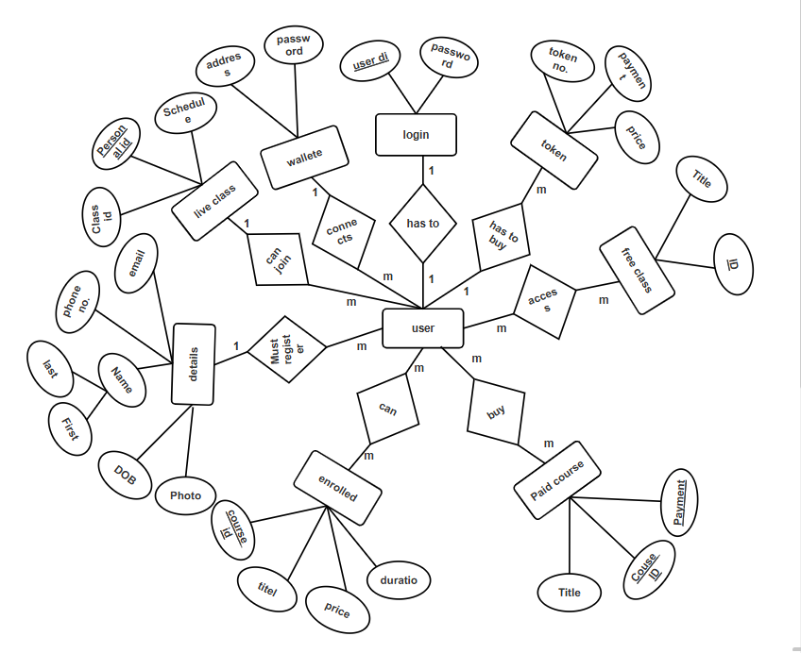

Figure 6.1 ER- Diagram for User

## 6.2 DATAFLOW DIAGRAM

It is a diagrammatic representationthat portrays the flow of datain a system or a process. Helps communicates the general data flowstructure of a proposed system to the system designer, programmer, and end-users.

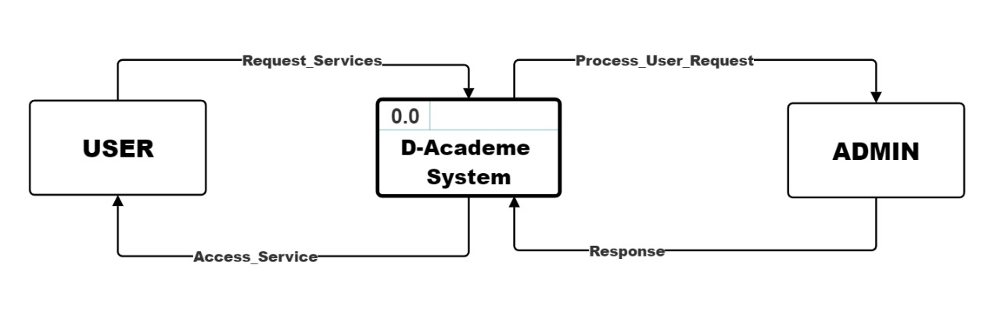

Figure 6.2 Level-0, DFD

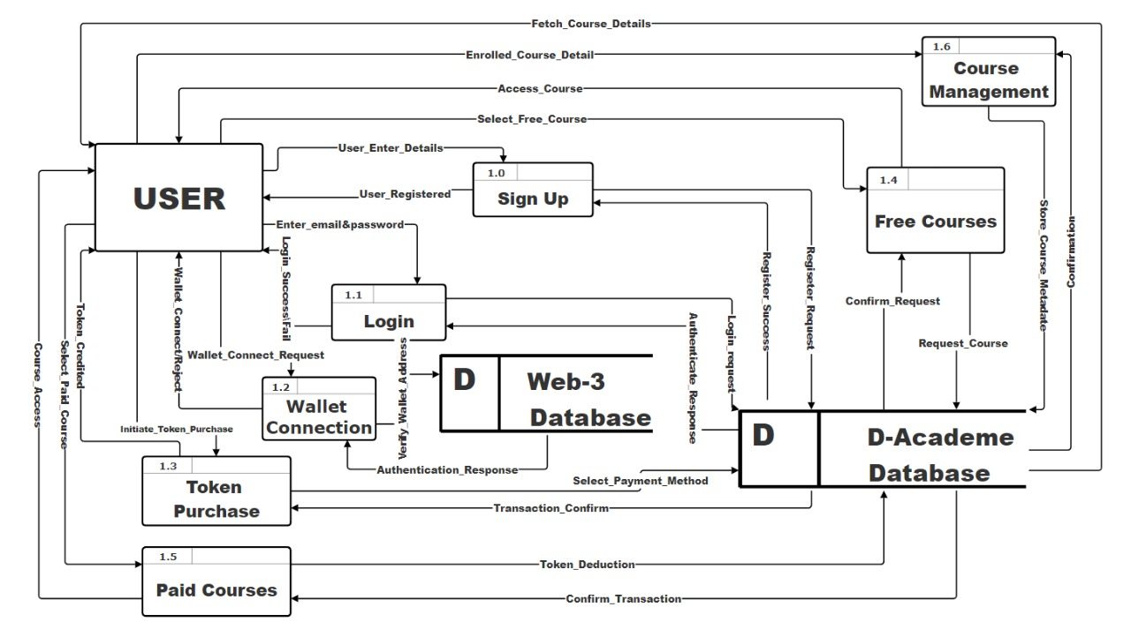

Figure 6.3 Level-1 DFD for User

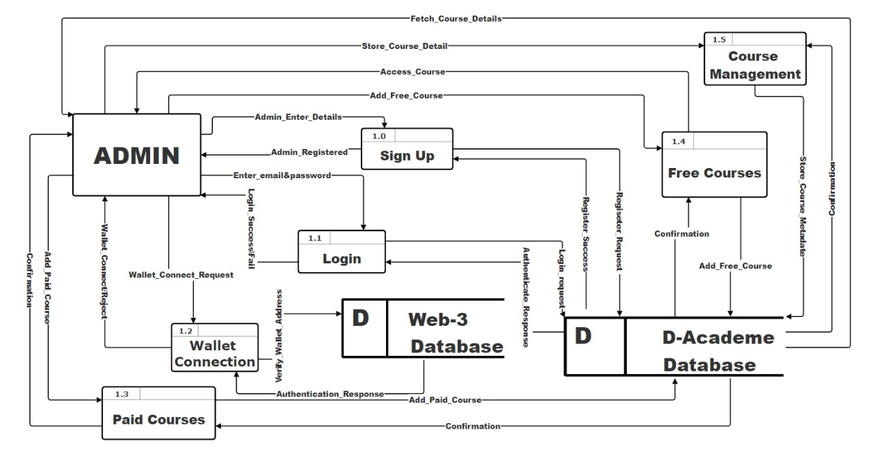

Figure 6.4 Level-1, DFD for admin

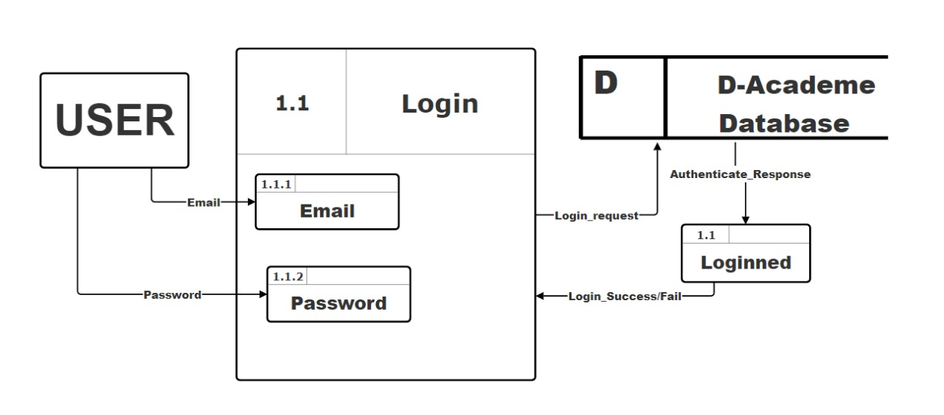

Figure 6.5 Level-2, DFD for user login

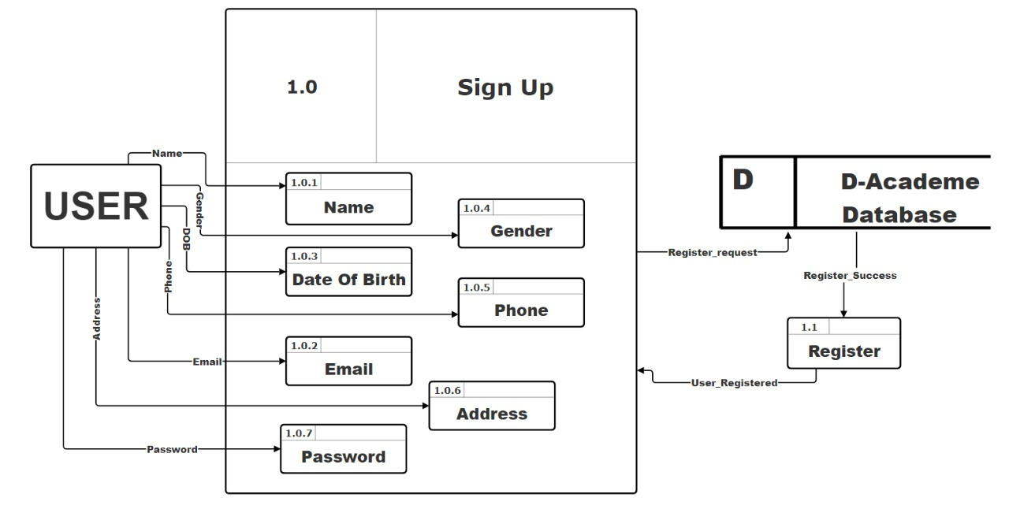

Figure 6.6 Level-2, DFD for User Register

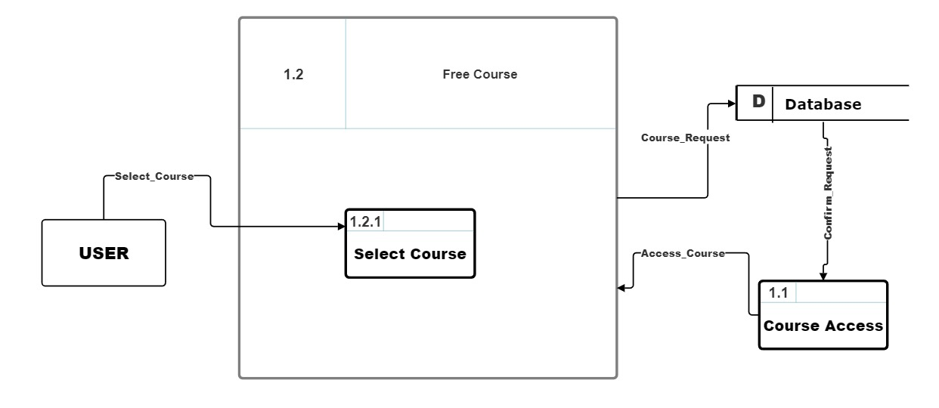

Figure 6.7 Level-2, DFD for free course

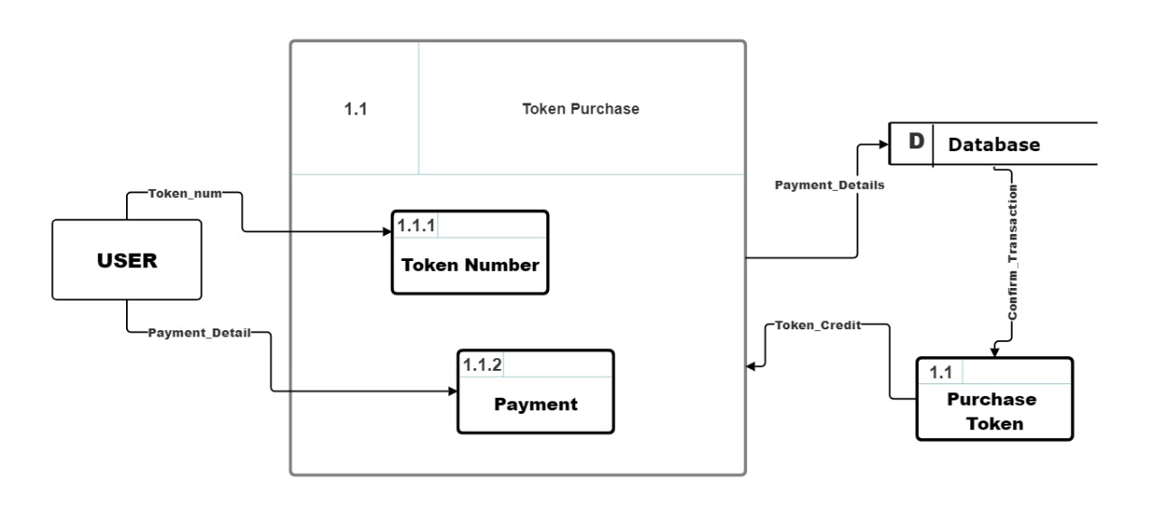

Figure 6.8 Level-2, DFD for token purchase

**DFD Index:**

|  |  |
| --- | --- |
| INDEX for User | |
| Function | SN |
| Sign up | 1.0 |
| Login | 1.1 |
| Wallet Connection | 1.2 |
| Token Purchase | 1.3 |
| Free course | 1.4 |
| Paid Courses | 1.5 |
| Course Management | 1.6 |

# METHODOLOGY

The Spiral Model is used in this project. A sophisticated method for developing software, the spiral model offers a framework for taking on challenging tasks and refining and assessing risks iteratively. The model is shown as a spiral, where each loop or phase denotes a different step in the process of evolution. It serves as the foundation for the majority of software development processes, which include planning, risk analysis, engineering, and evaluation.

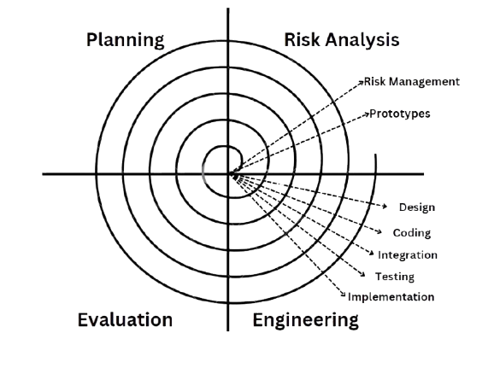

Figure 7.1 Spiral Model

The phases in Spiral model are: -

## 7.1 Planning Phase

The project's goals, parameters, and extent are specified at the planning phase. In order to determine the resources, deadlines, and deliverables, stakeholders collaborate. In order to create a strong basis for the project, requirements collecting and preliminary feasibility study are also completed during this phase.

## Risk Analysis

The spiral model's most unique characteristic is its risk analysis. Prototypes and models are used in this phase to identify, assess, and mitigate potential risks. To lower the chance of failure, the development team evaluates operational, financial, schedule-related, and technological risks.

## Engineering

This is the real development phase, during which system design, testing, and coding are done. The product is built incrementally, with every cycle resulting in a deliverable or prototype that changes with each iteration.

## Evaluation

Stakeholders assess the current build or prototype at the end of each cycle. Testers, clients, and end users all provide feedback. In the following iteration, the product might see improvements or adjustments in response to this input. This stage assists in guaranteeing that the product meets the expectations of the user.

# PROJECT GANTT CHART/ TIMELINE CHART

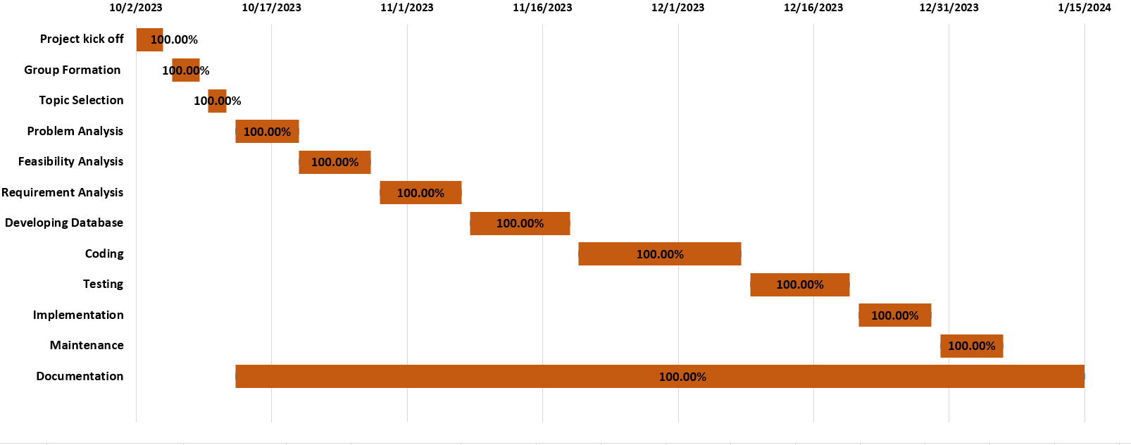

Figure 8.1: Timeline chart

|  |  |  |
| --- | --- | --- |
| INDEX | | |
| S. No. | Color | Work Status |
| 1 | Orange | Completed |
| 2 | Blue | Not completed |

1. **Work Assigned**

The different task identified for the compilation of the project were divided among the team members, with accordance to their talent and capabilities, and performed accordingly. Later they were integrated together to form a single unit. The division of task between four of us is tabulated below.

|  |  |  |  |
| --- | --- | --- | --- |
| S.N. | Name of the member | Work assigned | Remarks |
| 1. | Sangam Subedi | Documentation and System Design   * Requirements Document * Problem Identification * System Designs * Coding for some particular part |  |
| 2. | Prabin Shrastha | Documentation   * Compilation of documents into reports * Proposal planning * Support in System Design * Coding for some particular part |  |
| 3. | Amit Baral | Coding and System Design,   * Coding of major modules   Mention all the modules.   * Logic definition |  |
| 4. | Prabin ,Amit, Sangam | * Documentation, testing, and coding * Test matrix design, data testing, module testing, |  |

# TESTING

# PROJECT RESULTS

The D-Academe platform has ensured transformative outcomes in the realm of online education. Its architecture and real-time interactivity ensure extended access to learning that is more engaging and inclusive. It further provided seamless course management for both learners and educators, bright live learning sessions, and blockchain certification for transparency and trust in credentials.

These discussion forums and peer reviews are part of the collaborative tools that have grown a sense of community and knowledge sharing, hence enriching the learning experience. The decentralized model empowers users in active participation during decision-making, hence making the platform align with the principles of equity and fairness. This is showing great potential for scalability and adaptability for diverse educational objectives without losing performance and security.

D-Academe addressed the constraints of the conventional education system quite well with sustainable and innovative learning practices. This platform, using advanced technology, will facilitate an engaging, inclusive, and learner-centered environment; hence, it can change the educational environment in a way that will be commensurate with global objectives of equitable and lifelong learning opportunities.

# FUTURE ENHANCEMENTS

1. Chat box Integration:

Introduce an interactive chat box for real-time communication between learners, educators, and support teams.

1. AI Integration:

Implement AI-powered features like personalized course recommendations, automated feedback, and intelligent chat assistants for 24/7 user support.

# CONCLUSION

In conclusion, D-Academe successfully establishes a decentralized, interactive, and secure platform that addresses the limitations of traditional education systems. By leveraging innovative technologies and fostering collaboration, the platform enhances accessibility, engagement, and inclusivity, paving the way for a more sustainable and learner-centric educational future.

# ANNEXURES